Lab 13
VLAN Trunking
Objective:
The purpose of this lab is for the student to understand VLAN trunking. Students will also utilize IOS commands to explore and configure trunks.
Diagram:

Components:
6 – PC’s with an Ethernet NIC
2 – Switches
2 – 2 Port Routers
Procedure:
- Connect all PC’s together and put their static IP addresses, subnet masks and gateways on them. Test connectivity by pinging each machine within the network.

- On the diagram, label the routing tables below.

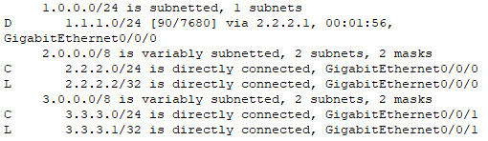
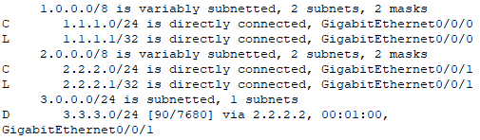

- Label the physical ports that the devices plug into on the switch on the diagram below.

- Label the chart below with what device is plugged into each switch port and what VLAN it should be on.

Switch 1:

Port Device VLAN
FastEthernet0/1 PC 1 1
FastEthernet0/2 PC 2 2
FastEthernet0/3 PC 3 3
FastEthernet0/22 Router 1 1
FastEthernet0/23 Router 1 2
FastEthernet0/24 Switch 2 TRUNK

Switch 2:

Port Device VLAN
FastEthernet0/1 PC 4 1
FastEthernet0/2 PC 5 2
FastEthernet0/3 PC 6 3
FastEthernet0/4 Router 2 2
FastEthernet0/5 Router 2 3
FastEthernet0/6 Switch 1 TRUNK

- View the status of all the ports on the switch

  - What command did you enter?
Show interface status

  - What VLAN are all of the switch ports in? VLAN 1

  - Why? VLAN 1 is the default VLAN

- Place FastEthernet0/24 into trunk mode on switch 1 and switch 2

  - What command did you enter?
Interface fa0/24
Switchport trunk encapsulation dot1q
Switchport mode trunk

- View the status of the trunk

  - What command did you enter?
Show interface status, show interface trunk
  - What vlans are going through the trunk?
VLAN 1-1005

- How could we have the same connectivity without using a trunk?
We would need one connection between each switch for every VLAN

- Place the other used switch ports into access mode and into the proper vlans on both switches.

- Verify the trunk is properly working.

  - Can 1.1.1.10 ping 1.1.1.11? Yes
  - Can 2.2.2.10 ping 2.2.2.11? Yes
  - Can 3.3.3.10 ping 3.3.3.11? Yes

- Enable the router interfaces and place IP addresses on them.

- View Router 1’s routing table.

  - What routes are displayed?
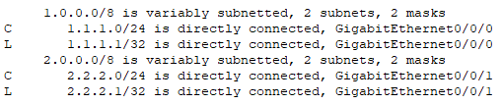
  - What routes are missing?
Network 3

- View Router 2’s routing table.

  - What routes are displayed?
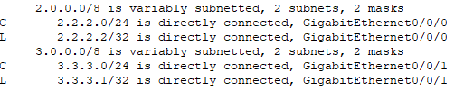

  - What routes are missing?
Network 1
- Enable static routing on Router 1

  - What command did you enter?
Ip route 3.3.3.0 255.255.255.0 2.2.2.2

- Enable static routing on Router 2

  - What command did you enter?
Ip route 1.1.1.0 255.255.255.0 2.2.2.1

- Can 1.1.1.10 ping 3.3.3.11? Yes

- Remove Router 2 and disconnect 1 interface from Router1.

- Label the routers routing table below.

- Clear any previous IP address information from Router 1.

- Make the switch port that Router 1 plugs into a trunk port

  - Why does this need to be a trunk port?
So that the router port can use all the VLANs – “corn dog” protocol or Router on a Stick

- Create a sub-interface FastEthernet0/0.1

  - What command did you enter?
Int gi0/0/0.1

- Place the sub-interface FastEthernet0/0.1 into VLAN 1

  - What command did you enter?
Encapsulation dot1q 1

- Give the sub-interface FastEthernet0/0.1 an IP address 1.1.1.1/24

  - What command did you enter?
Ip address 1.1.1.1 255.255.255.0

- View the routing table

  - Is the 1.1.1.0/24 network shown in the routing table?
Yes

- Create a sub-interface FastEthernet0/0.1, place it in vlan 1, give it an IP address of 1.1.1.1/24, and turn the interface on

  - What commands did you enter?
Int gi0/0/0.1
Encapsulation dot1q 1
Ip address 1.1.1.1 255.255.255.0
No shutdown

- Create a sub-interface FastEthernet0/0.2, place it in vlan 2, give it an IP address of 2.2.2.1/24, and turn the interface on

  - What commands did you enter?
Int gi0/0/0.2
Encapsulation dot1q 2
Ip address 2.2.2.1 255.255.255.0
No shutdown

- Create a sub-interface FastEthernet0/0.3, place it in vlan 3, give it an IP address of 3.3.3.1/24, and turn the interface on

  - What commands did you enter?
Int gi0/0/0.3
Encapsulation dot1q 3
Ip address 3.3.3.1 255.255.255.0
No shutdown

- View the routing table

  - Are all networks shown in the routing table? Yes

- Can 1.1.1.10 ping 3.3.3.11? Yes

- What is the name of the current router configuration?

Router on a stick

- Is this optimal for bandwidth or was the previous configuration with 2 routers better?
For bandwidth’s sake, the 2 routers are better
  - Why? The two router set up had four different interfaces to handle the same traffic that the new configuration has only one interface

- Please “write erase” your routers and switch(es). Also, Delete your vlan.dat file by issuing the following command: (delete flash:vlan.dat) on the switches. Not necessary on the routers.

- Draw the lab diagram below (PC’s, switch, and router connections) Label the IP addresses, and subnet masks of each device. Feel free to use packet tracer or Visio, but do not copy and paste the diagram at the beginning of the lab. Screen shot your diagram and paste it below. Label the routing tables next to the routers. Label VLAN and TRUNKS next to switches.

